MACH4METAL

metalworking machinery
Transito 21
6909 DA BABBERICH Netherlands
Tel. +31 (0)316-247123
Fax: +31 (0)316-247956
info@mach4metal.com
www.mach4metal.com

Bank No : 66.52.13.883
IBAN : NL33 INGB 0665 2138 83
BIC : INGBNL2A
www.mach4metal.com

Schunk permanent Magnetik table
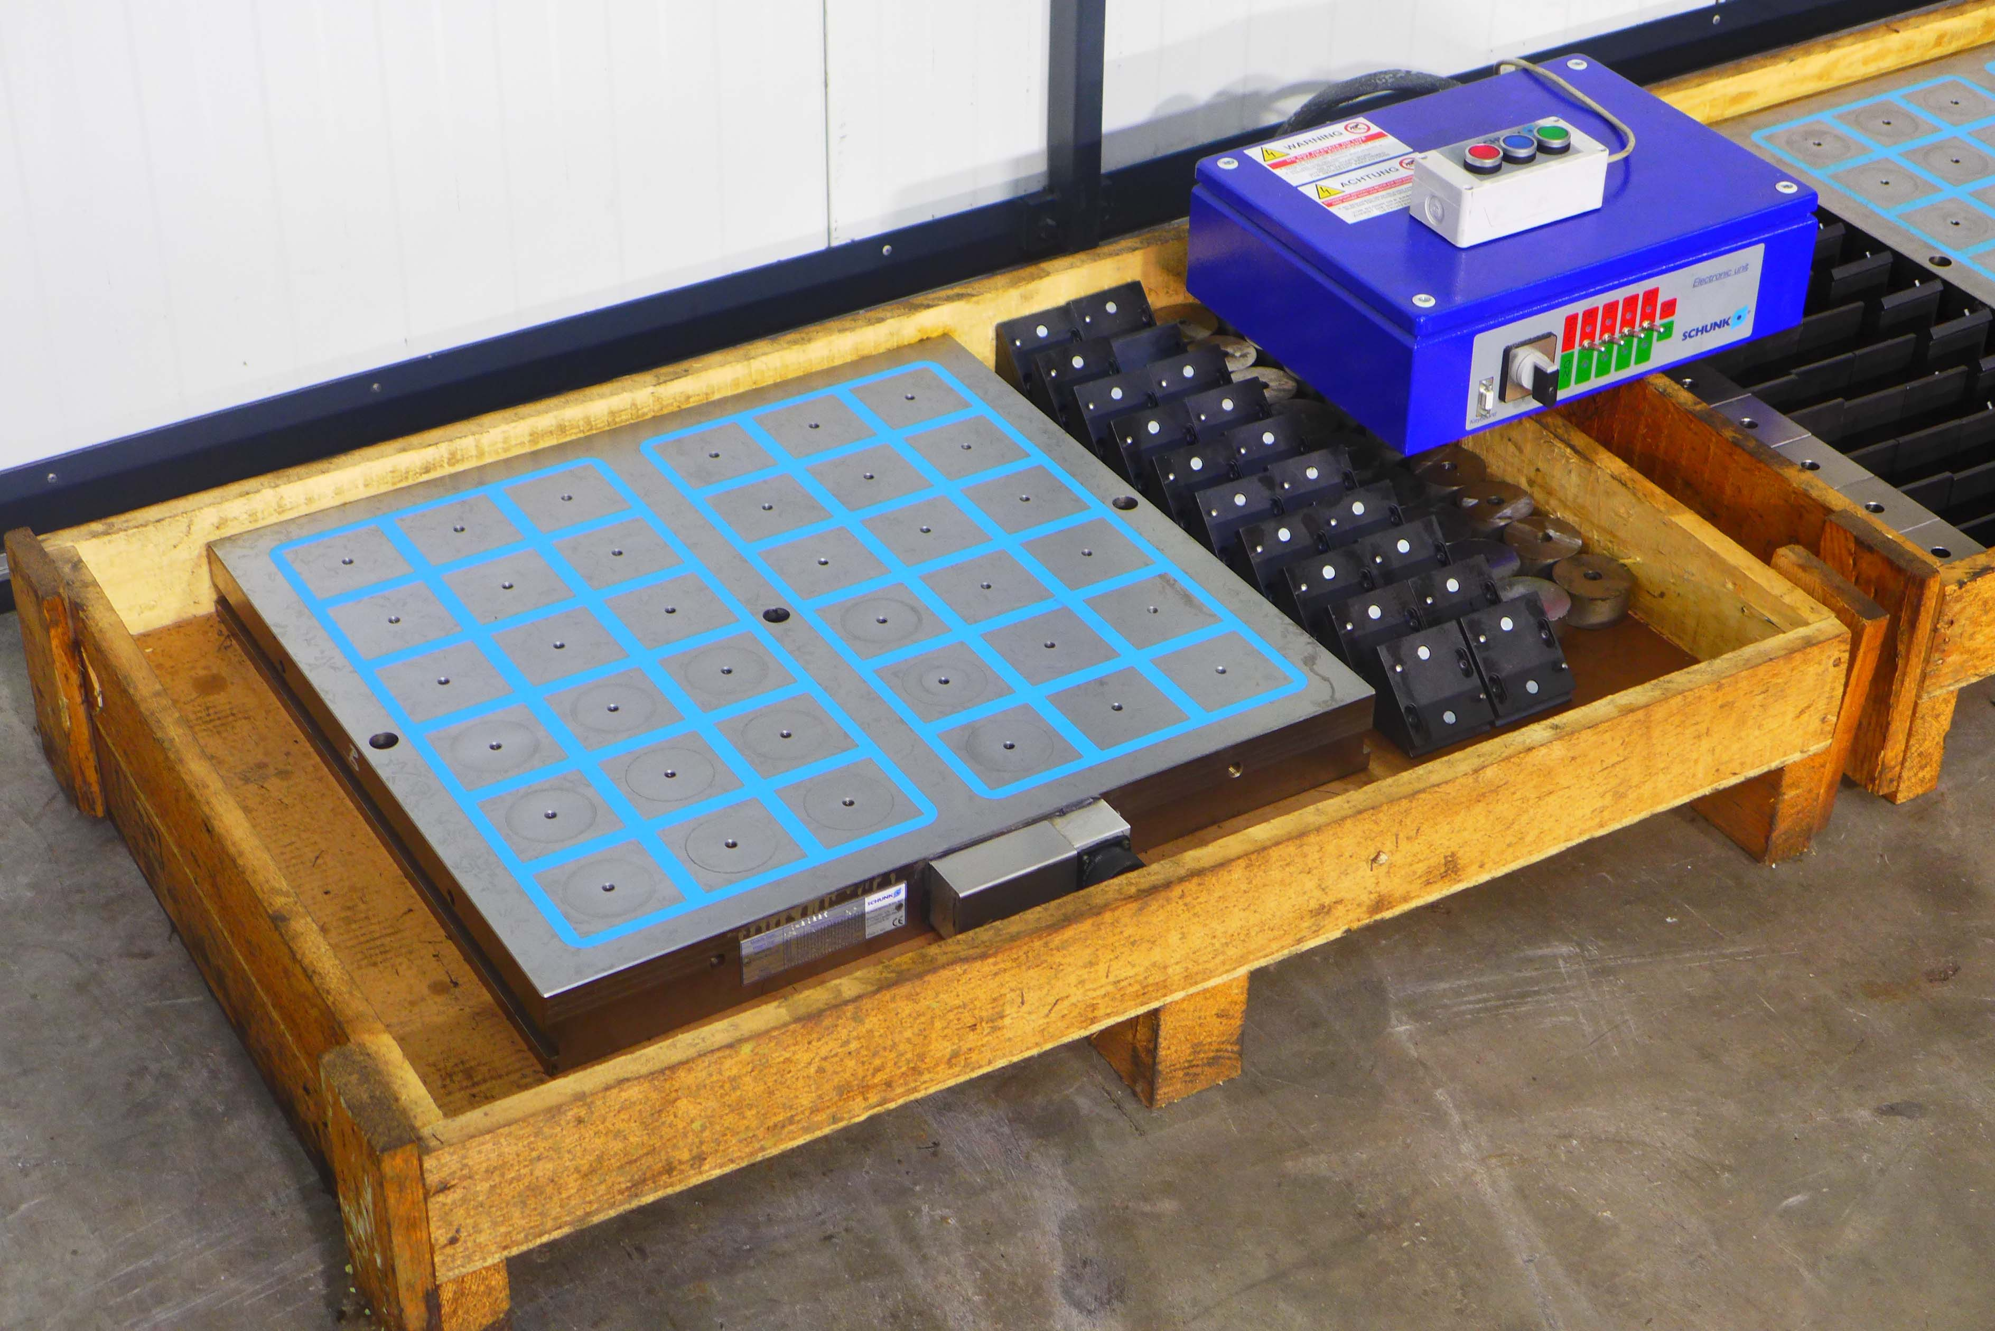
- Make : SCHUNK - Germany
- Typ : MFR 1 – 075 – 060 - 060
- Age : 2007
- Mach. No. : 3364 / 07

- Table length : 630
- Table width : 580
- Table height :

- Number of poles : 36
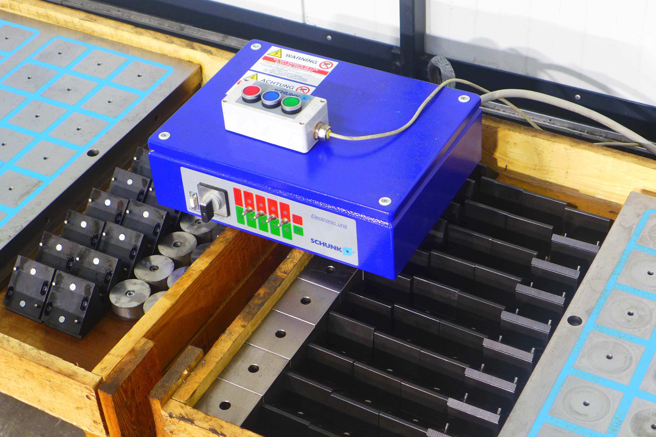
- Pole thread : M8
- Size off pole : 50 x 50
- Force per pole : 380 daN

- Weight off table : 148 kg
- Version with block / spacers

- incl. SCHUNK Electronic unit QU 04
SCHUNK KEH 01 rapid connector with
sealed cover.

- Very, little used…

Please Note: The above information has been obtained to the best of our ability and belief from, and from the manufacturers where possible. It is given in good faith, but its accuracy can not be guaranteed. Accordingly, it will not form a representation or constitute contractual terms. We advise you to check any vital details!

